Use of Master Artisans in Design Workshops

In the course of designing products for the groups, the designer might be inspired to create a certain product, based upon the skills of the group. But perhaps extra technical training is needed for which the designer needs to locate an expert.
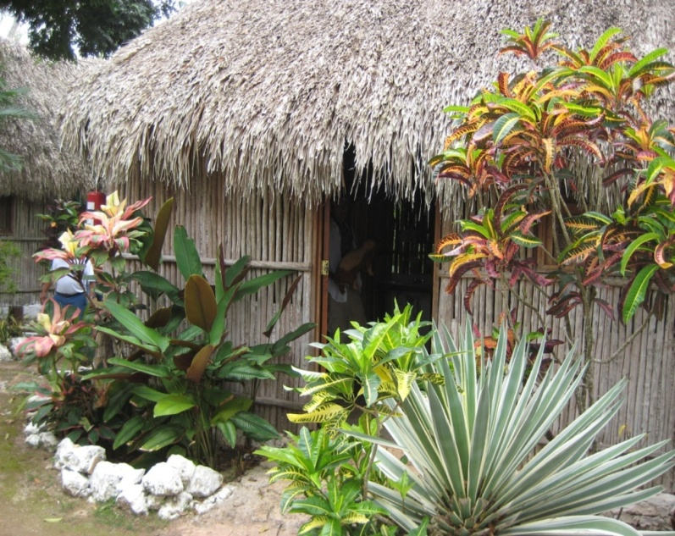
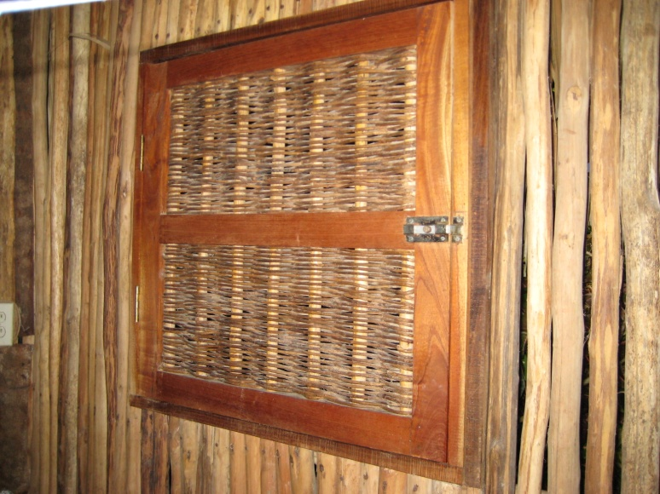
This situation occurred in Nuevo Durango, a tiny village surrounded by a forest of trees downed during Hurricane Wilma. I was sent there to help them determine what they could do with the acres of twisted, dry trees left in the hurricane’s wake. The village was being threatened by forest fires due to the immense quantities of dry wood surrounding it. People lamented that there was not a quantity of straight pieces of wood in the forests, from which they could produce lumber and begin to try fine woodworking.
The community had already developed a small business of eco-tourism, guiding visitors through nearby caves. As an added attraction, they built charming guest cabañas, nicely appointed with furniture made out of green branches. They also made doors and windows out of woven vines.
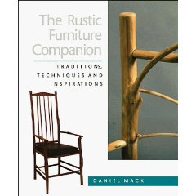
I am an admirer of the American designer Daniel Mack’s delightful rustic furniture. His book, “Rustic Furniture Companion” had enchanted me with his whimsical and beautiful work. Daniel is a master woodworker and furniture designer in this genre, with an eye to seeing the beauty and possibilities in wood which others would assign to the burn pile.
It seemed a far-fetched possibility that Daniel Mack would even consider volunteering to come and teach the people of Nuevo Durango what they could create with their dry trees. But I had to try…Daniel Mack is also a teacher of his art and they needed his training and inspiration.
I emailed Daniel telling him of the opportunity to make a difference in the lives of people from this tiny village. To my great delight, he answered that he would consider it and we communicated back and forth to iron out the details.
As far as I was concerned, it was practically a miracle that such an expert was coming to work with the people. He agreed to spend ten days, which would be divided between two other groups as well.
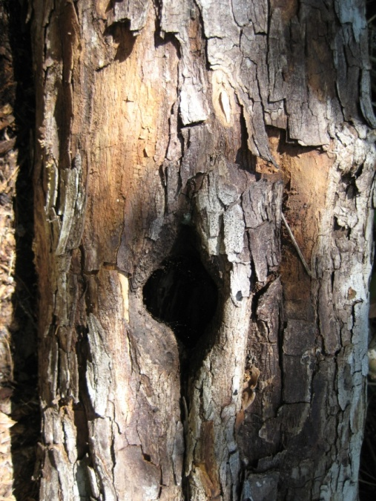
In Nuevo Durango, the people immediately could tell what a fine soul Daniel was, even though he could not speak a word of Spanish. They communicated through sign–language and by working together, with him doing a process first and then the others repeating it. I acted as a translator when necessary, though I soon discovered that he was able to communicate with them on a level more universal than language.
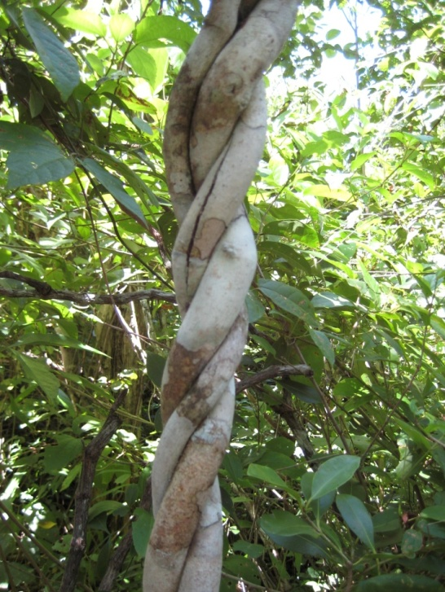
Daniel instilled in the people ability to value the character of a gnarled branch, spiraled with indentations from a vine which girdled it or a piece of wood with holes bored into it by a woodpecker. He called these the marks which “tell the story of the forest and the life within it.” These characteristics made it unique, a natural work of art and something which urban dwellers, yearning for a touch of nature in their lives, would cherish. No two pieces could ever be alike.
After enlightening them as to the amazing resource they had surrounding them, he trained them in how to use the rustic wood to make fine furniture. Just because it is rustic, does not mean poorly made.
Realizing that the women were not used to working with heavy tools, he decided to have them create miniatures. They learned about joining the pieces of wood and about finishes, either leaving on the interesting bark or peeling it and polishing it softly with linseed oil and beeswax.
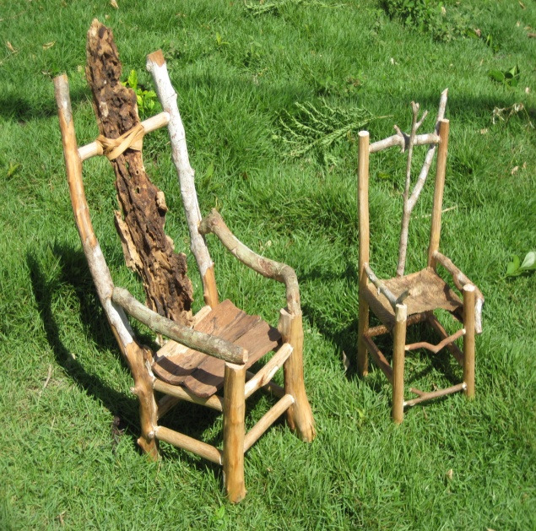
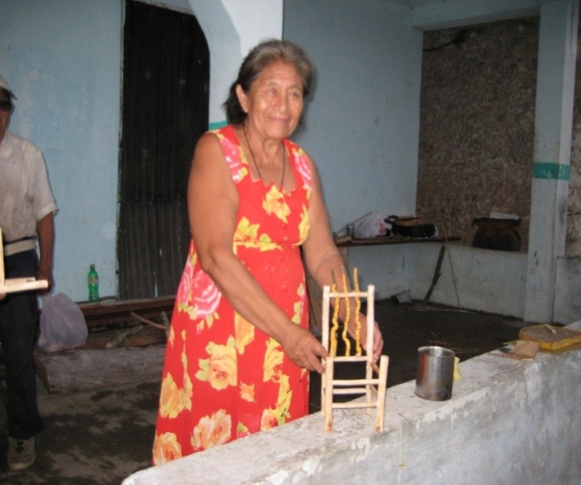
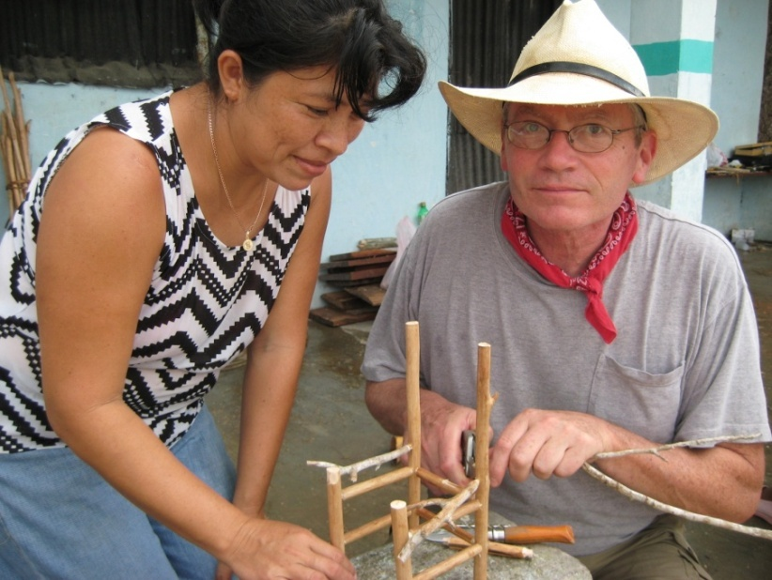

They were encouraged to let their imaginations run wild with the possibilities of the natural materials around them: the brown “fabric” of the palm tree, feathers from the woods, dried stems and pods. These began to form fantasy chairs which the group decided to call “Alux Chairs” after the tiny spirit people of their woods which most had truly encountered.
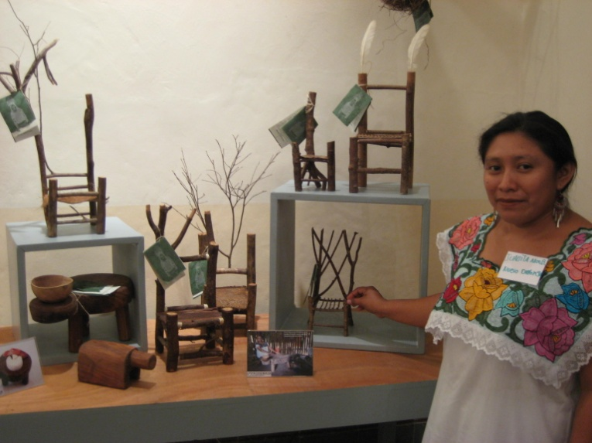
During the days Daniel spent with the people of Nuevo Durango, we created tiny chairs, human-scale chairs and the beginnings of the miniature tortilla-making table and bench. A year later, two of the women were the lucky recipients of an opportunity to participate in one of Daniel Mack’s workshops in Rustic Furniture at Omega Institute, in rural New York to further refine their design abilities.
The visit of Daniel Mack inspired lasting appreciation for and recognition of rustic beauty in the people of Nuevo Durango. They have continued to sell their line of “Alux Chairs,” miniature tortilla tables and benches, as well as other rustic accessories for the home through the project PRODEMAYA.

This same program was used for other groups in the Prodemaya project. Montserrat Altes was invited to teach women in Tabasco, Jose Maria Morelos how to make mobiles out of natural materials and Maruja Barbachano taught jewelry design to these same women.
The inclusion of other experts in any field enriches the design experience for the participants and is highly recommended.

